Generalized Linear models

GLM.3 <- glm(Core.health.workforce.density ~ che_pc_usd, family=Gamma(log), data=SynthesisModels)

> summary(GLM.3)

Call:
glm(formula = Core.health.workforce.density ~ che_pc_usd, family = Gamma(log),
data = SynthesisModels)

Coefficients:
Estimate Std. Error t value Pr(>|t|)
(Intercept) 2.5900041 0.1106899 23.399 < 2e-16 ***
che_pc_usd 0.0036936 0.0005161 7.156 0.00000000598 ***
---
Signif. codes: 0 '***' 0.001 '**' 0.01 '*' 0.05 '.' 0.1 ' ' 1

(Dispersion parameter for Gamma family taken to be 0.3714679)

Null deviance: 43.469 on 46 degrees of freedom
Residual deviance: 17.274 on 45 degrees of freedom
AIC: 365.75

Number of Fisher Scoring iterations: 6

Interpretation
exp(Intercept)*exp(che_pc_usd) would be the core density with a 1 unit increase in che_pc_usd
That is, increase in 1 USD per capita will lead to an increase of core workforce by 1.0037 odds
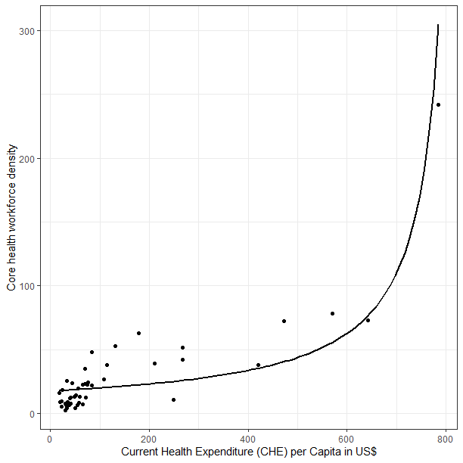

GLM.8 <- glm(Dentists ~ che_pc_usd, family=gaussian(identity), data=SynthesisModels)

> summary(GLM.8)

Call:
glm(formula = Dentists ~ che_pc_usd, family = gaussian(identity),
data = SynthesisModels)

Coefficients:
Estimate Std. Error t value Pr(>|t|)
(Intercept) -0.066638 0.107220 -0.622 0.537
che_pc_usd 0.004159 0.000500 8.318 1.19e-10 ***
---
Signif. codes: 0 '***' 0.001 '**' 0.01 '*' 0.05 '.' 0.1 ' ' 1

(Dispersion parameter for gaussian family taken to be 0.3485428)

Null deviance: 39.799 on 46 degrees of freedom
Residual deviance: 15.684 on 45 degrees of freedom
AIC: 87.799

Number of Fisher Scoring iterations: 2
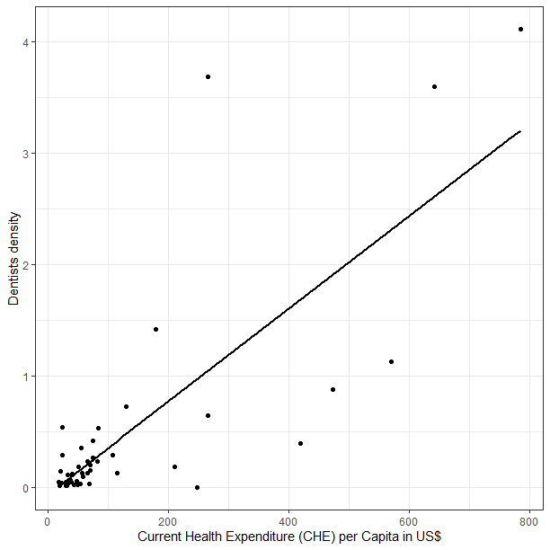

GLM.16 <- glm(Doctors ~ che_pc_usd, family=Gamma(log), data=SynthesisModels)

> summary(GLM.16)

Call:
glm(formula = Doctors ~ che_pc_usd, family = Gamma(log), data = SynthesisModels)

Coefficients:
Estimate Std. Error t value Pr(>|t|)
(Intercept) 0.5835637 0.1184717 4.926 0.0000117739 ***
che_pc_usd 0.0037266 0.0005524 6.746 0.0000000243 ***
---
Signif. codes: 0 '***' 0.001 '**' 0.01 '*' 0.05 '.' 0.1 ' ' 1

(Dispersion parameter for Gamma family taken to be 0.4255345)

Null deviance: 41.512 on 46 degrees of freedom
Residual deviance: 16.878 on 45 degrees of freedom
AIC: 176.78

Number of Fisher Scoring iterations: 5

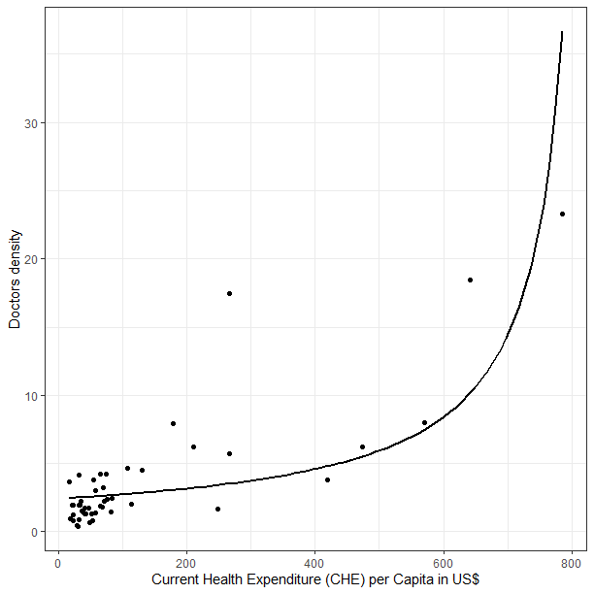

GLM.14 <- glm(Nurses ~ che_pc_usd, family=Gamma(log), data=SynthesisModels)

> summary(GLM.14)

Call:
glm(formula = Nurses ~ che_pc_usd, family = Gamma(log), data = SynthesisModels)

Coefficients:
Estimate Std. Error t value Pr(>|t|)
(Intercept) 2.1672445 0.1252570 17.30 < 2e-16 ***
che_pc_usd 0.0036269 0.0005841 6.21 0.000000152 ***
---
Signif. codes: 0 '***' 0.001 '**' 0.01 '*' 0.05 '.' 0.1 ' ' 1

(Dispersion parameter for Gamma family taken to be 0.4756738)

Null deviance: 46.097 on 46 degrees of freedom
Residual deviance: 21.930 on 45 degrees of freedom
AIC: 332.53

Number of Fisher Scoring iterations: 6

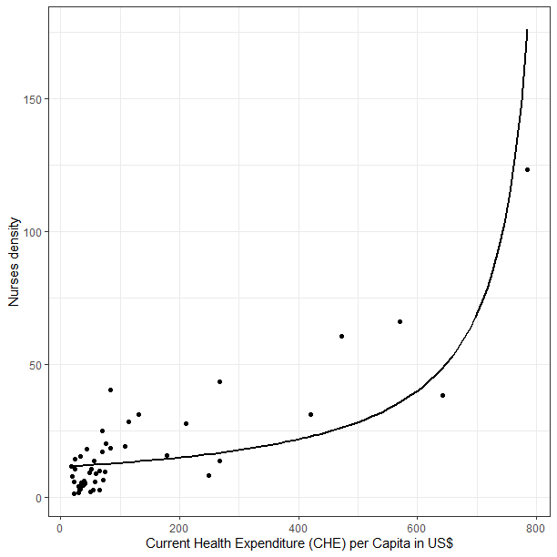

GLM.15 <- glm(Pharmacists ~ che_pc_usd, family=Gamma(log), data=SynthesisModels)

> summary(GLM.15)

Call:
glm(formula = Pharmacists ~ che_pc_usd, family = Gamma(log),
data = SynthesisModels)

Coefficients:
Estimate Std. Error t value Pr(>|t|)
(Intercept) -0.8303025 0.1703605 -4.874 0.000013987 ***
che_pc_usd 0.0045074 0.0007944 5.674 0.000000949 ***
---
Signif. codes: 0 '***' 0.001 '**' 0.01 '*' 0.05 '.' 0.1 ' ' 1

(Dispersion parameter for Gamma family taken to be 0.8799207)

Null deviance: 79.498 on 46 degrees of freedom
Residual deviance: 40.053 on 45 degrees of freedom
AIC: 74.433

Number of Fisher Scoring iterations: 6

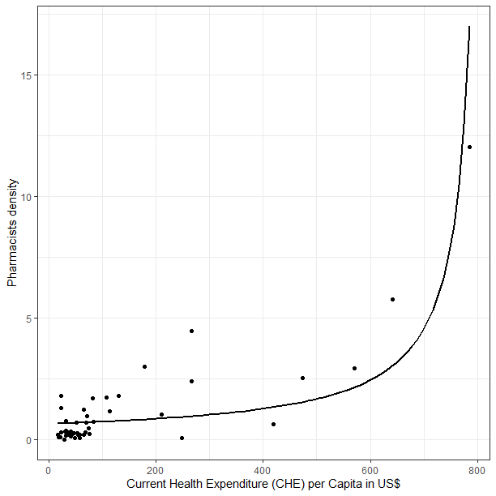

GLM.18 <- glm(Midwives ~ che_pc_usd, family=gaussian(identity), data=SynthesisModels)

> summary(GLM.18)

Call:
glm(formula = Midwives ~ che_pc_usd, family = gaussian(identity),
data = SynthesisModels)

Coefficients:
Estimate Std. Error t value Pr(>|t|)
(Intercept) 1.852077 0.567938 3.261 0.00212 **
che_pc_usd 0.007341 0.002648 2.772 0.00807 **
---
Signif. codes: 0 '***' 0.001 '**' 0.01 '*' 0.05 '.' 0.1 ' ' 1

(Dispersion parameter for gaussian family taken to be 9.7793)

Null deviance: 515.21 on 46 degrees of freedom
Residual deviance: 440.07 on 45 degrees of freedom
AIC: 244.51

Number of Fisher Scoring iterations: 2

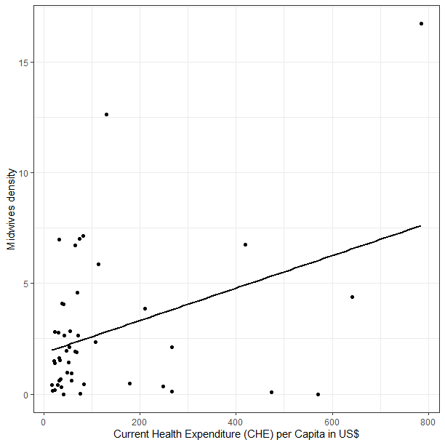

And with the map you can play with thresholds and ranges (which do not need to be linear or of the same size for each category) for example a red to green color scale (7-8 shades) and the change from red to green could be based on SDG threshold...

So that you can see countries "becoming green" between 2013 and 2022 by crossing this arbitrary threshold.

(great triangulation work on education data Dr Christmal, very helpful) I am disconnecting now to another call. Thanks for the great discussion. Have a nice day.

Call:
lm(formula = Core.health.workforce.density ~ che_pc_usd, data = synthesis)

Residuals:
Min 1Q Median 3Q Max
-47.971 -5.693 -0.923 5.493 95.366

Coefficients:
Estimate Std. Error t value Pr(>|t|)
(Intercept) 5.39218 3.80561 1.417 0.163
che_pc_usd 0.18001 0.01775 10.144 3.32e-13 ***
---
Signif. codes: 0 '***' 0.001 '**' 0.01 '*' 0.05 '.' 0.1 ' ' 1

Residual standard error: 20.95 on 45 degrees of freedom
Multiple R-squared: 0.6957, Adjusted R-squared: 0.689
F-statistic: 102.9 on 1 and 45 DF, p-value: 3.319e-13

Call:
lm(formula = Service.capacity.and.access ~ Core.health.workforce.density,
data = synthesis)

Residuals:
Min 1Q Median 3Q Max
-30.503 -8.282 -3.260 6.413 49.557

Coefficients:
Estimate Std. Error t value Pr(>|t|)
(Intercept) 21.83271 2.54374 8.583 4.96e-11 ***
Core.health.workforce.density 0.35812 0.05438 6.585 4.21e-08 ***
---
Signif. codes: 0 '***' 0.001 '**' 0.01 '*' 0.05 '.' 0.1 ' ' 1

Residual standard error: 13.86 on 45 degrees of freedom
Multiple R-squared: 0.4907, Adjusted R-squared: 0.4794
F-statistic: 43.36 on 1 and 45 DF, p-value: 0.00000004214

